Nicholas Shari

CSE422

Homework #5

Due: 12/6/2022

Problems: 1,2,5,8,9,10,14,18,21,22,26,31

P1. Suppose the information content of a packet is the bit pattern 1110 0110 1001 1101 and an even parity scheme is being used. What would the value of the field containing the parity bits be for the case of a two-dimensional parity scheme? Your answer should be such that a minimum length checksum field is used.

1 0 0 0 1

0 1 1 0 0

1 0 0 1 0

1 1 0 1 1

1 0 1 0 0

P2.Show (give an example other than the one in Figure 6.5 ) that two-dimensional parity checks can correct and detect a single bit error. Show (give an example of) a double-bit error that can be detected but not corrected.

No errors Single Bit Error

1 0 0 0 1 1 0 0 0 1

0 1 1 0 0 0 1 1 0 0

1 0 0 1 0 1 1 0 1 0

1 1 0 1 1 1 1 0 1 1 Detectable since the parity bits align.

1 0 1 0 0 1 0 1 0 0

1 0 0 0 1

0 1 1 0 0

1 1 1 1 0 Detectable. But not correctable.

1 1 0 1 1 If we change row 3, col 3 back to 0.

1 0 1 0 0 Col 3 is fixed, but now row 3 has an error.

P5. Consider the 5-bit generator,G=10011, and suppose that D has the value 1010101010. What is the value of R?

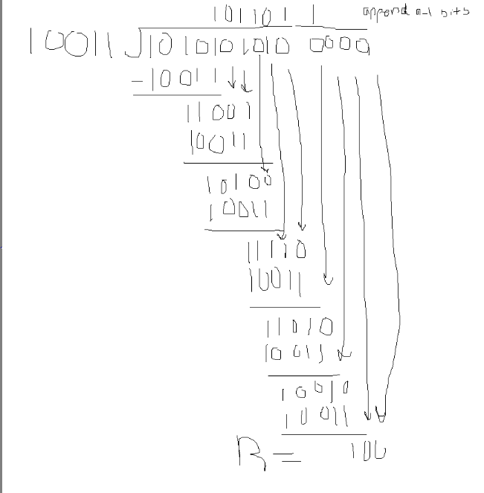

Therefore, Remainder = 0100

P8. In Section 6.3 , we provided an outline of the derivation of the efficiency of slotted ALOHA. In this problem we’ll complete the derivation.





P9. Show that the maximum efficiency of pure ALOHA is 1/(2e).

Note: This problem is easy if you have completed the problem above!

P 10. Consider two nodes, A and B, that use the slotted ALOHA protocol to contend for a channel. Suppose node A has more data to transmit than node B, and node A’s retransmission probability pA is greater than node B’s retransmission probability, pB .







P14. Consider three LANs interconnected by two routers, as shown in Figure 6.33 .

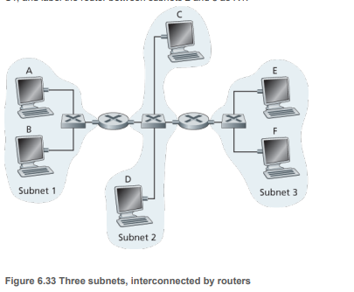

a. Assign IP addresses to all of the interfaces. For Subnet 1 use addresses of the form 192.168.1.xxx; for Subnet 2 uses addresses of the form 192.168.2.xxx; and for Subnet 3 use addresses of the form 192.168.3.xxx.

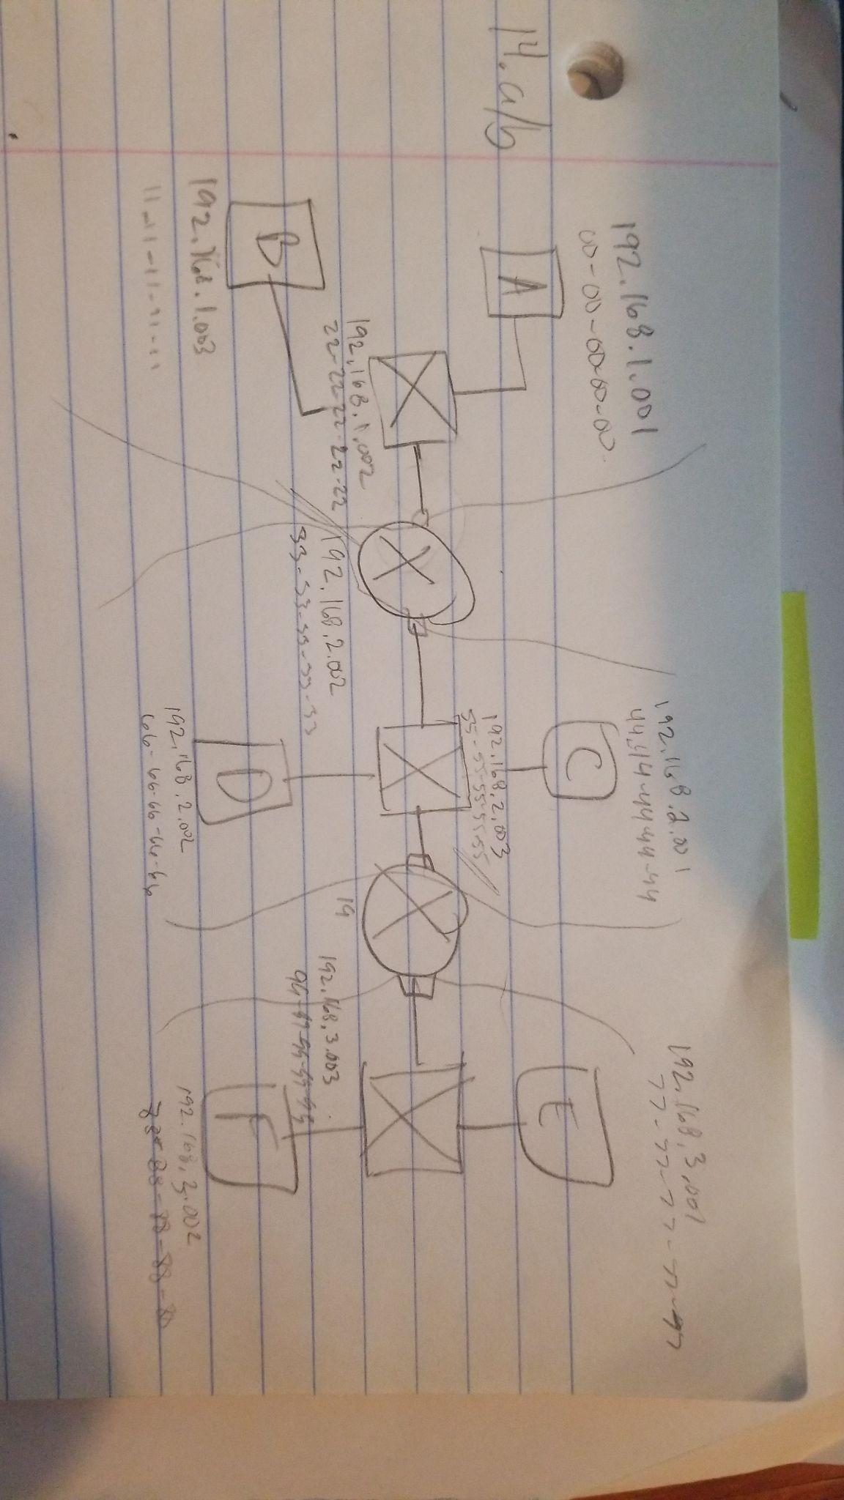

b. Assign MAC addresses to all of the adapters.

c. Consider sending an IP datagram from Host E to Host B. Suppose all of the ARP tables are up to date. Enumerate all the steps, as done for the single-router example in Section 6.4.1 .

1. E checks its forwarding table and knows to send the datagram to router(192.168.3.003)
2. The adapter at E makes an ethernet packet with its destination MAC address of 99-99-99-99-99(address of router 2).
3. Router2 uses its forwarding table to send the datagram to router1(192.168.2.002).
4. Router 2 sends out an ethernet packet with the source MAC address of B and the destination MAC at Router1(33-33-33-33-33)
5. Router1 directs the datagram to B(192.168.1.003)

d. Repeat (c), now assuming that the ARP table in the sending host is empty (and the other tables are up to date).

E has to find Router 2 by sending out a broadcast message with ARP.

Router 2 will receive a broadcast packet and sends E an ARP response ticket.

The previous 1-5 steps then occur.

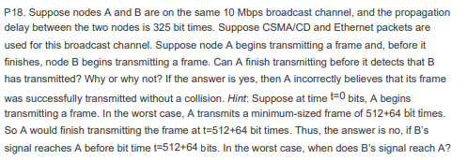

t = 0 : A begins transmitting frame of 576 bit

t = 324 : Moment before first frame of A arrives at B with prop delay of 325.

t = 649 (324+325) : time for A to B and back. (Worst case)

576 bits are sent before 649 bit time. Therefore, A thinks there is no collision.

P21. Consider Figure 6.33 in problem P14. Provide MAC addresses and IP addresses for the interfaces at Host A, both routers, and Host F. Suppose Host A sends a datagram to Host F. Give the source and destination MAC addresses in the frame encapsulating this IP datagram as the frame is transmitted (i) from A to the left router, (ii) from the left router to the right router, (iii) from the right router to F. Also give the source and destination IP addresses in the IP datagram encapsulated within the frame at each of these points in time.



i) from A to the left router,

Source MAC: 00-00-00-00-00 Destination MAC: 22-22-22-22--22

Source IP: 192.168.1.001 Destination IP: 192.168.1.002

(ii) from the left router to the right router,

Source MAC: 33-33-33-33-33 Destination MAC: 55-55-55-55-55

Source IP: 192.168.2.002 Destination IP: 192.168.2.003

(iii) from the right router to F

Source MAC: 99-99-99-99-99 Destination MAC: 88-88-88-88-88

Source IP: 192.168.3.003 Destination IP: 192.168.3.002

P22. Suppose now that the leftmost router in Figure 6.33 is replaced by a switch. Hosts A, B, C, and D and the right router are all star-connected into this switch. Give the source and destination MAC addresses in the frame encapsulating this IP datagram as the frame is transmitted (i) from A to the switch, (ii) from the switch to the right router, (iii) from the right router to F. Also give the source and destination IP addresses in the IP datagram encapsulated within the frame at each of these points in time

i) from A to the switch,

Source MAC: 00-00-00-00-00 Destination MAC: 55-55-55-55-55

Source IP: 192.168.1.001 Destination IP: 192.168.2.003

(ii) from the switch to the right router,

Source MAC: 00-00-00-00-00 Destination MAC: 55-55-55-55-55

Source IP: 192.168.1.001 Destination IP: 192.168.2.003

(iii) from the right router to F

Source MAC: 99-99-99-99-99 Destination MAC: 88-88-88-88-88

Source IP: 192.168.3.003 Destination IP: 192.168.3.002

P26. Let’s consider the operation of a learning switch in the context of a network in which 6 nodes labeled A through F are star connected into an Ethernet switch.

Suppose that (i) B sends a frame to E,

(ii) E replies with a frame to B,

(iii) A sends a frame to B, (iv) B replies with a frame to A.

The switch table is initially empty. Show the state of the switch table before and after each of these events. For each of these events, identify the link(s) on which the transmitted frame will be forwarded, and briefly justify your answers.

| Action | Switch Table Before | Switch Table After | Links transmitted frame forwarded to | Justify |
| --- | --- | --- | --- | --- |
| B sends to E | empty | MAC B | A,C,D,E,F | The switch table is empty. Therefore it does not know E’s MAC address. So it broadcasts to all. |
| E replies to B | MAC B | MAC B, MAC E | B | The switch already knows B’s MAC address. |
| A send to B | MAC B,MAC E | MAC B,MAC E, MAC A | B | The switch already knows B’s MAC address. |
| B replies to A | MAC B,MAC E, MAC A | MAC B,MAC E, MAC A | A | The switch already knows A’s MAC address. |

P31. In this problem, you will put together much of what you have learned about Internet protocols. Suppose you walk into a room, connect to Ethernet, and want to download a Web page. What are all the protocol steps that take place, starting from powering on your PC to getting the Web page? Assume there is nothing in our DNS or browser caches when you power on your PC. (Hint: The steps include the use of Ethernet, DHCP, ARP, DNS, TCP, and HTTP protocols.) Explicitly indicate in your steps how you obtain the IP and MAC addresses of a gateway router.